In Memory of our Brother…
I don't care how long my brother is gone; we still miss him terribly and have a hole in our lives without him. A few years ago, someone contacted me saying he had been with my brother when he was killed. He said that Terry was very anxious to get home to see his little girl that he hadn't seen yet ... and I said ... what little girl? We have no knowledge of this and sometimes feel like there is someone else out there that misses him as much as we do. Just an emotional response, I know, but it still pulls on the heartstrings.
Connie (Smith) Bullock and Jim Smith

TERRANCE EDWARD SMITH
Phillipsburg, NJ
2/14 Inf., 25th Inf. Div
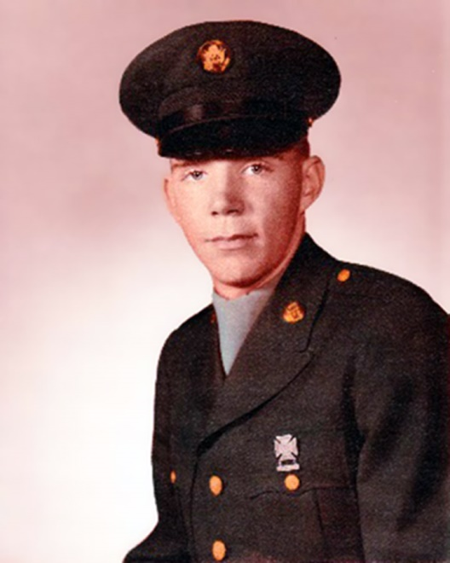
Panel 46E-Row 012
Terrance served as a - Staff Sergeant - Grade E6 - Army - Drafted Selective Service

He was 20 years old at the time of his death
Terry was born on June 19, 1947 in Phillipsburg, NJ.
His Tour of duty began in Vietnam on April 23, 1967
Terry served with (B) Company, 2nd Battalion, 14th Infantry, 25th Division
Terry died at 8:30 AM on March 24, 1968 outside the Town of Trang Bang, in Tay Ninh Province.
His death was a result of Hostile small arms fire.
[Terry was struck in the head while fighting for the lives of his men and comrades.]
Please read his Silver Star commendation below.

Terrance Edward Smith, a Drafted Selective Service Soldier with a 2 year service obligation, attained the rank of Staff Sergeant. It is virtually unheard of for a Soldier to attain this rank and command a Platoon of men with less than 2 years of service. Sergeant Terrance Smith accomplished this with 2 consecutive battlefield promotions.

A Soldier’s Soldier, Sergeant Smith was awarded:

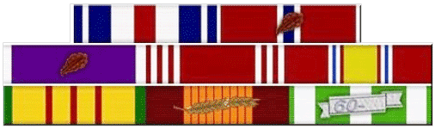
Silver Star Medal (3rd highest award that can be awarded to a soldier) for Gallantry in Action
2 Bronze Star Medals (one with Oak Leaf Cluster) for meritorious service against hostile forces
2 Purple Hearts for wounds received on two separate occasions
National Defense Service Medal
Vietnam Service Medal
Vietnam Campaign Ribbon with 1960 Device
Good Conduct Medal
The Republic of Vietnam, Military Merit Medal:
The Republic of Vietnam, Gallantry Cross with Palm
The Combat Infantryman Badge
Vietnam War Streamers:
• Counteroffensive, Phase II 1 July 1966-31 May 1967
• Counteroffensive, Phase III 1 June 1967-29 January 1968
• Counteroffensive, Phase V 1 July-1 November 1968

Silver Star commendation:
For Gallantry in Action, Staff Sergeant Smith distinguished himself by heroic actions on March 24, 1968, while serving as a platoon sergeant with Company B, 2nd Battalion, 14th Infantry on a combat operation in the Republic of Vietnam. When his unit was pinned down by intense enemy fire, Sergeant Smith reacted instantly to the situation and led his platoon to protective cover. He repeatedly exposed himself to the enemy fire to direct his men's fire and when a group of his men were trapped by the enemy fire he maneuvered to their position. After maneuvering these men to within 25 meters of the friendly positions, Sergeant Smith was mortally wounded by the intense enemy fire. His valorous actions saved several lives and were of immeasurable value to the successful completion of the mission. Sergeant Smith's personal bravery, aggressiveness, and devotion to duty are in keeping with the highest traditions of the military service and reflect great credit upon himself, his unit, the 25th Division, and the United States Army. Authority, by the direction of The President of The United States, under the provisions of the Act of Congress, approved July 9, 1918.

